**Term Project Assignment Report**

**Introduction**

The Viterbi decoder is an algorithm used for decoding convolutional codes, which are commonly used in error correction systems. It aims to determine the most likely sequence of transmitted bits given the received sequence.

**Resource Utilization**

Logic Elements : 508   
Registers : 254  
Memory Bits : 34.816

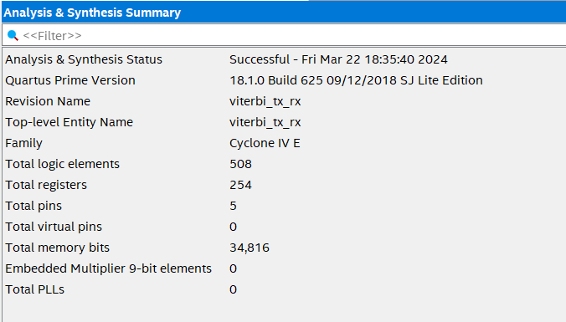

**RTL Schematic :**

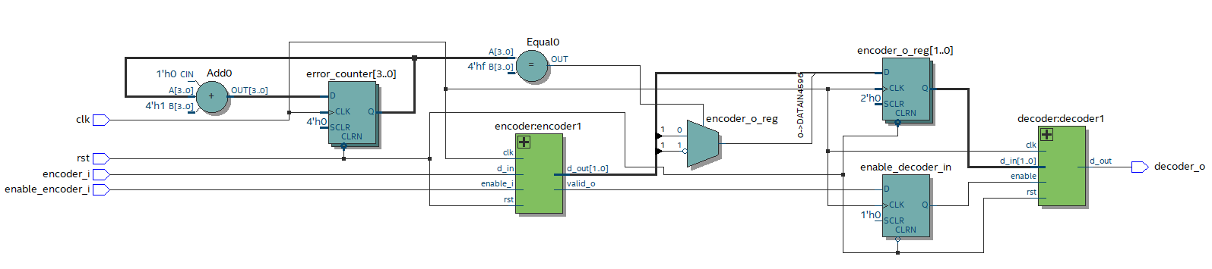

**Post Mapping Schematic:**

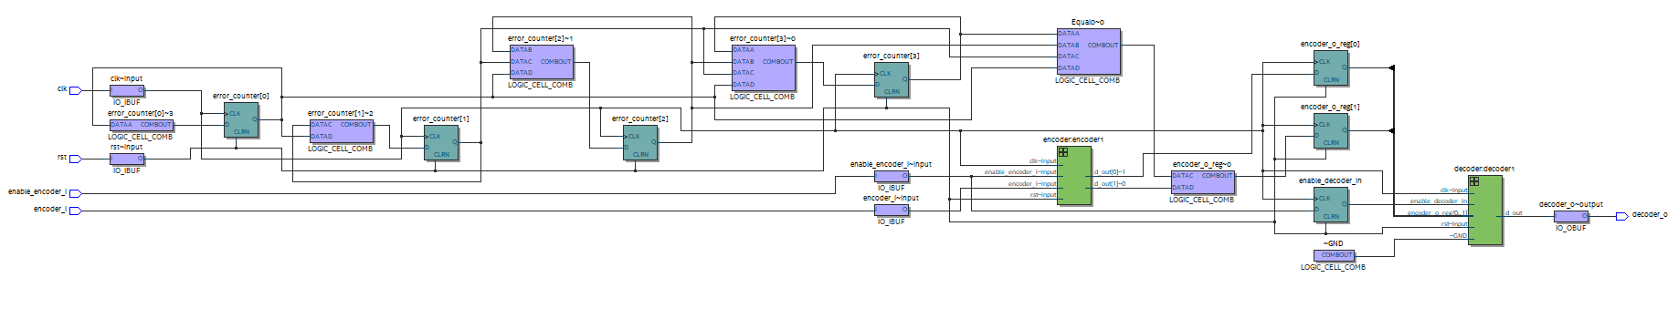

**Transcript**

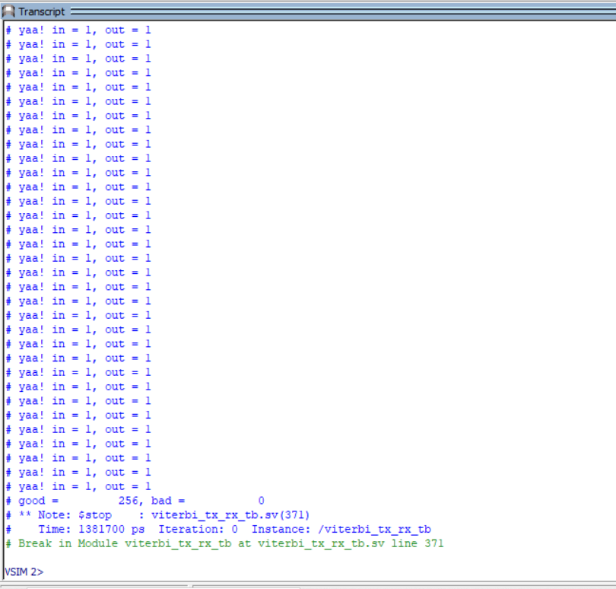

**How the encoder works:**

**How the decoder works:** The received sequence is passed to the Viterbi decoder. The decoder has knowledge of the encoder's structure and the code's constraints, such as the code rate and the generator polynomials.   
The decoder uses a trellis diagram, which represents all possible paths through the encoder based on the code constraints. The Viterbi algorithm determines the most likely path through the trellis. The algorithm starts in an initial state and evaluates all possible paths from that state to each subsequent state. At each stage, the decoder calculates a metric, known as the branch metric, for each possible transition. The branch metric represents the distance or dissimilarity between the received sequence and the possible transmitted sequence for that transition. The algorithm then selects the path with the minimum cumulative metric at each stage. This process continues until the final state is reached, and the path with the minimum cumulative metric is considered the most likely transmitted sequence.

**The minimum branch metric = 0 when no errors are present:**The branch metric represents the dissimilarity between the received sequence and the possible transmitted sequence for a specific transition in the trellis. When no errors are present, the received sequence perfectly matches the transmitted sequence, resulting in a minimum branch metric of 0. That’s why we got score 256/256 with no errors.